fall 2024
Cse-4355/5355 Electromechanical Systems and Sensors
the university of texas at arlington


lab 6 report
Submitted toward the partial completion of the requirements for CSE 4355/5355
Under the guidance of
Prof. Jason Losh
By:
Dario Ugalde, 1001268068
Joshua Martinez, 1001374818

Introduction
In this lab, we are introduced to thermocouples. They are devices meant to measure the temperature in their environment by converting thermal energy into an electrical one. Their composition is made of two different metal/alloys and typically welded together at one end, whereas the other has a voltage reader attached. Based on the temperature at the junction, a certain amount of voltage is created and sent to the reader. For this lab, we will experiment with Type K thermocouples alongside an ADS1115 A/D converter. The main objective for this lab is to accurately measure temperature through the difference between the cold junction and the thermocouple junction. A temperature-to-voltage and voltage-to-temperature functions will operate a lookup table to inform us of each value while completing this lab. Through this lab, we will be able to measure temperature through an electrical conversion of three extremes: dry ice, an ice bath, and a soldering iron.

Pre-Lab Setup and Preparation
This lab will require usage of type K thermocouples and methods to capture their temperature/voltage measurements. The specific version we will be using has a predefined reference table stating the voltage output based on the temperature difference with the reference junction at 0 Celsius. For our use case, a look up table based on the reference table’s range of -80 to 300 Celsius and their voltages will be necessary. As this table is extensive and large, this was created before our appointed lab times. Other important code sections needed are temperature to voltage and voltage to temperature functions based on our table are required. Based on one of these measured values, these functions must search for the appropriate conversion of the adjacent value within the table. The methods for measuring this value will be explained in the next section. One last major function necessary is a temperature calculation based on the thermocouple voltage (Vcj + Vtc) and finding the actual temperature by referencing the table despite a proper cold junction value.

Reading Temperature
Under normal circumstances, the thermocouple’s cold junctions are usually submerged in an ice bath to have a 0°C offset when compared to the measuring end of the thermocouple. We did not make use of the ice bath with our thermocouple and as a result were required to calculate the room temperature offset prior to accessing values from the look-up table. To resolve this, we used a TMP36 temperature sense module. We wired up the thermocouple outputs to the ADS1115 AIN0 and AIN1, and the TMP36 output to AIN2. Figure 1 below shows our connections for this step. To read the temperature values from our sensors, we used the I2C0 library with our TM4C red board. This allowed us to set the appropriate values for our 2 devices in the config register of the ADS1115 and alternate reading thermocouple data and TMP36 data from the conversion register. By using our ADC readings, we could then calculate the voltage of each device based on the voltage offset for their associated lowest bit based on their configuration. These values are in a table within the ADS’s document. For the cold junction’s new voltage value, we multiplied it using a given formula to derive its temperature. For the thermocouple, the new value from multiplying its adc value with the offset gave a rough estimate. This value needs to be adjusted to give a proper temperature value during interpolation. Afterwards these two values are summed to find the total voltage measured by our devices. This sum value could then be used to perform a linear interpolation of the nearest 2 points on the voltage lookup table to determine our thermocouple’s final temperature value. The directions of the lab were straight-forward, however we ran into difficulty implementing the software in such a way that allowed us to get accurate measurements. After much difficulty we were unable to resolve the underlying issue, causing inaccurate readings by the deadline.
For testing temperatures, we used ice water, a soldering iron, and dry ice. The ice water, or ice, offered a 0 C temperature which is used as a base line. The dry ice should give a final temp of around -75 C if done properly, whereas the soldering iron is set at 400 C. These three temperature zones are used for a proper demonstration of our lab; however, as stated we had some difficulty. Figures 2 and 3 show our testing of ice water and the soldering iron during the lab. Figure 4 illustrates the outputs from the ADS converter onto our screen showing temp/volt conversions from our lab.

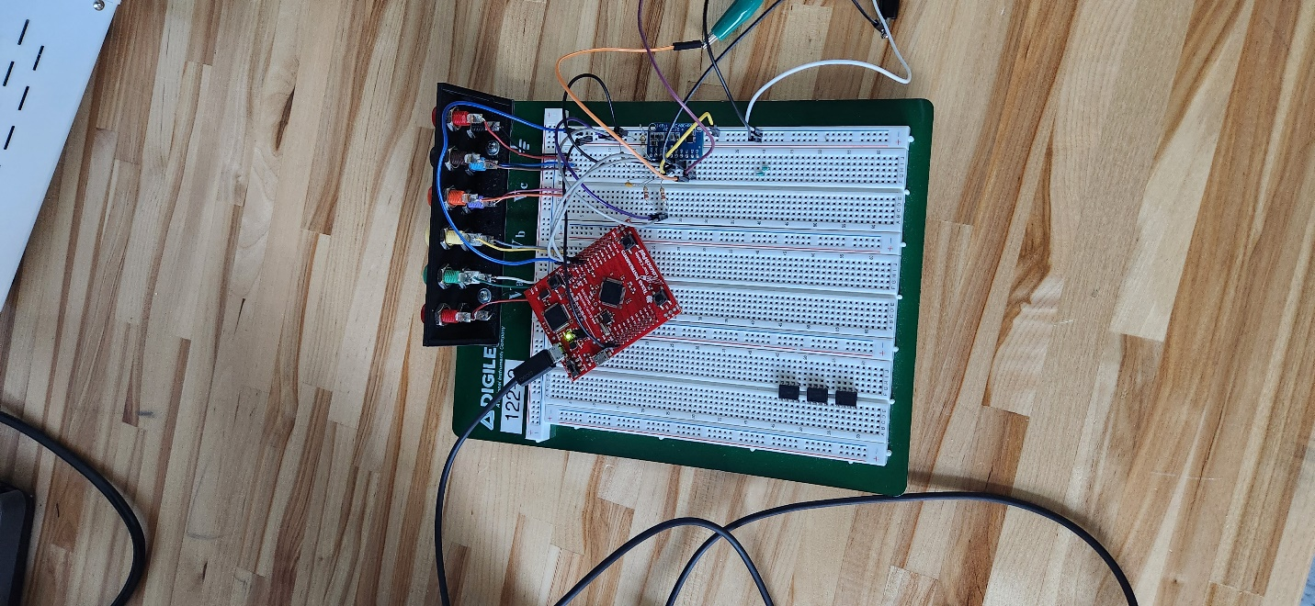

Figure 1: Image of connections from our red board to sensor/thermocouple

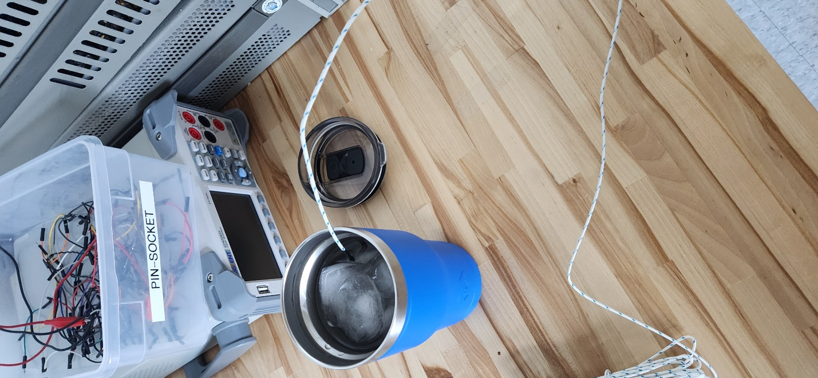
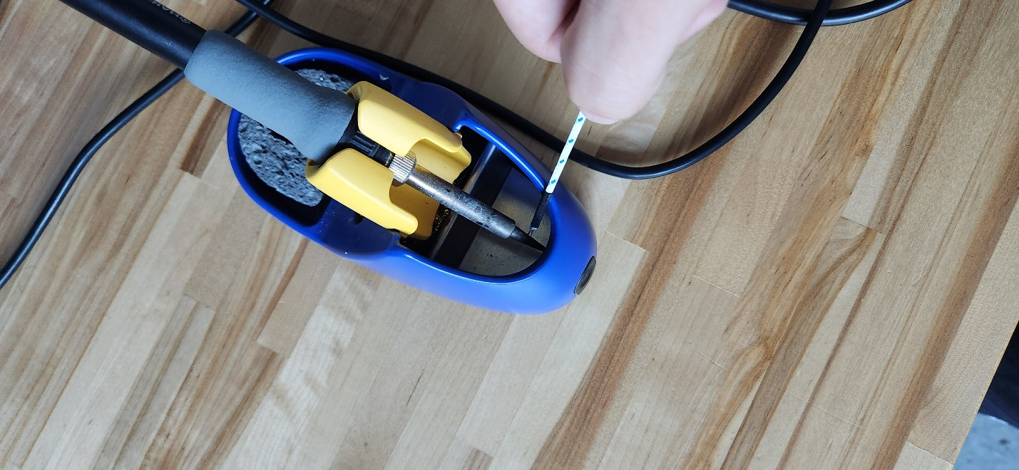
Figures 2 and 3: Images of testing and measuring temperatures using the thermocouple (ice water, and soldering iron)
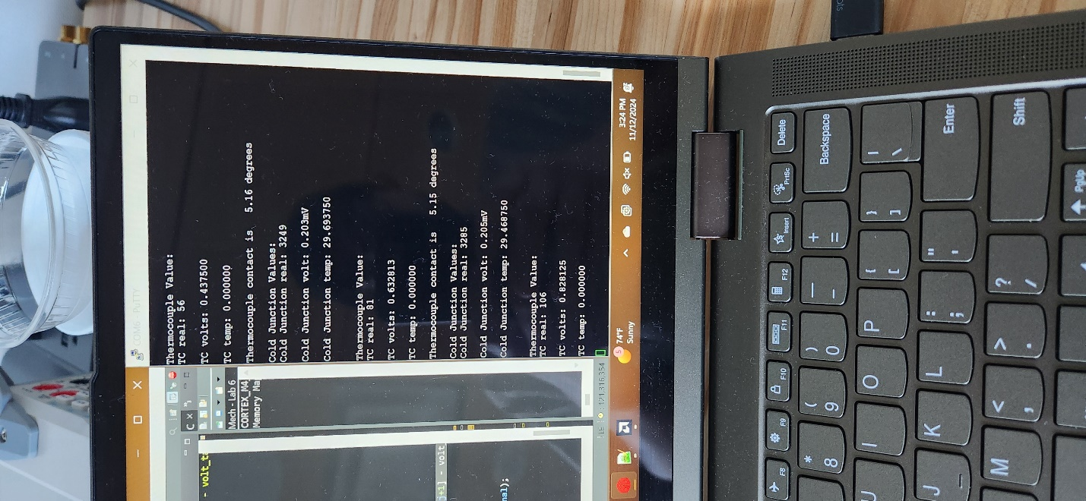

Figure 4: Image of the outputs from the ADS and voltage/temp conversions

Conclusion
This lab provided a practical example in the usage of thermocouples, sensors which have a wide range of measurable values. As we saw, they could measure values as cold as dry ice or as hot as a soldering iron. They also provide for a robust method of error detection due to the way the circuit is biased. Should the voltage match the bias, then a break in the circuit may have occurred. Although we ran into difficulty in our implementation, the concepts of this lab were easy to understand.
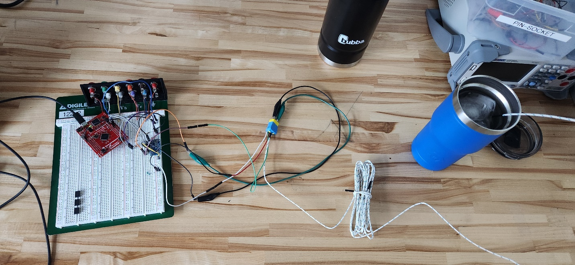

Final Setup for lab

Figure 5: Image of our setup during testing

